APPENDIX A. FORMULATION OF LAYERED ELASTIC ANALYSIS EQUATIONS

The compatibility equation for linear elastic behavior of a continuous body in cylindrical coordinates is:

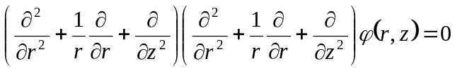 (A-1)

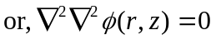 (A-2)

where:
z = vertical axis, positive downwards
r = radius from the vertical axis in the horizontal plane
(stresses and strains are constant in the horizontal plane for any r and z)

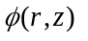is a stress function satisfying the equilibrium equations such that:

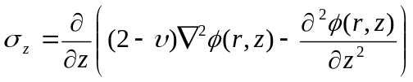 (A-3)

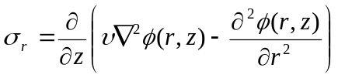 (A-4)

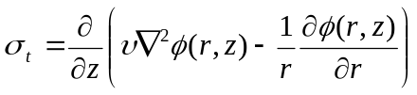 (A-5)

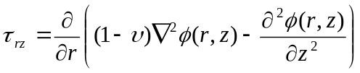 (A-6)

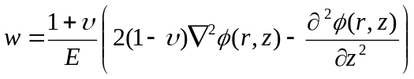 (A-7)

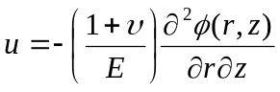 (A-8)

where:

σ_{z} = vertical stress
σ_{r} = radial stress in the horizontal plane
σ_{t} = tangential stress in the horizontal plane (perpendicular to σ_{r})
τ_{rz} = shear stress
w = vertical displacement
u = radial displacement
E = Young’s modulus
υ = Poisson’s ratio

When the stress function satisfies the compatibility equation the following conditions hold:

- displacement throughout the body is continuous;
- each elemental part of the body is in equilibrium; and
- stress and strain are related by Hooke’s law.

The equation given is correct for constant internal body forces, such as gravity, but not for cases where the body forces vary with r or z.

The problem now is to find a stress function which satisfies the compatibility equation. After the stress function has been found, it can be substituted into the stress and displacement equations to give numerical solutions.

To find the stress function, start by taking the zero order Hankel transform of the compatibility equation. This reduces the compatibility equation to an equation algebraic in the transform variable (α) and with complete differentials in z. The zero-order Hankel transform pair is:

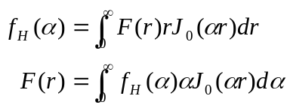 (A-9)

where 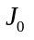 is the zero order Bessel function.

The Hankel transform of the compatibility equation is:

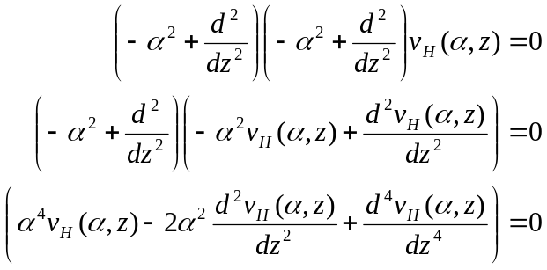 (A-10)

Performing the indicated operations results in an ordinary differential equation in z:

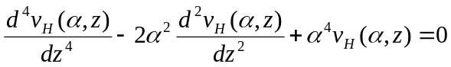 (A-11)

Now solve using the Laplace transform method:

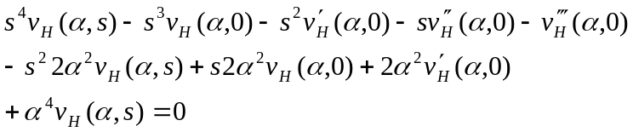 (A-12)

where 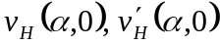, etc., are initial conditions of 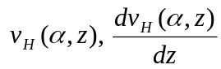, etc.

Therefore:

(A-13)

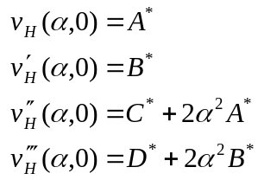 (A-14)

and

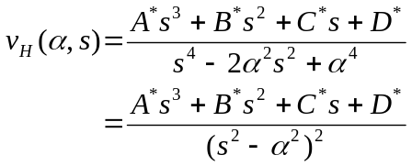 (A-15)

Solving for each term on the right hand side, and making use of mathematical identities (for example):

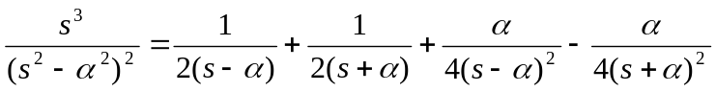

and

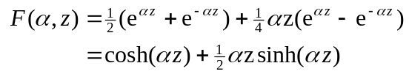
gives:

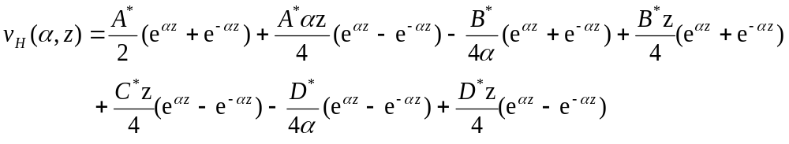 (A-16)

Or, expressed in hyperbolic functions:
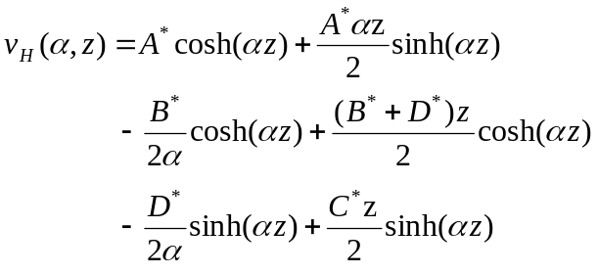 (A-17)

However, since the starred constants are undetermined functions of α, equation (A-17) can be simplified to:

(A-18)

The stress function can now be found by inverse Hankel transformation:

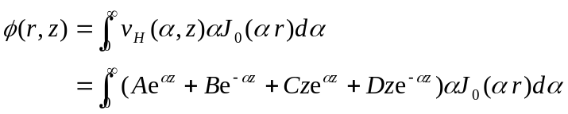 (A-19)

Equation (A-19) does not have an analytic solution and must be solved numerically for given values of α and z. The constants A, B, C, and D are found from the boundary conditions. The constants are functions of α and new values must be found at each step of the integration, which means that the complete stress function cannot be used to find the constants. However, the compatibility equation operations are all performed within the integral sign of the stress function and each elemental part of the integration is, itself, a stress function satisfying the compatibility equation. The integrand can therefore be substituted into the stress and displacement equations to find the constants at each value of α. Substituting the integrand into the equations for vertical and shear stresses and for vertical and radial displacements gives the “elemental” stresses and displacements:

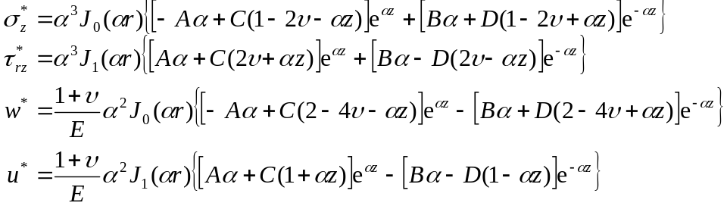 (A-20)

And the complete stresses and displacements, written to show the Hankel form, are:

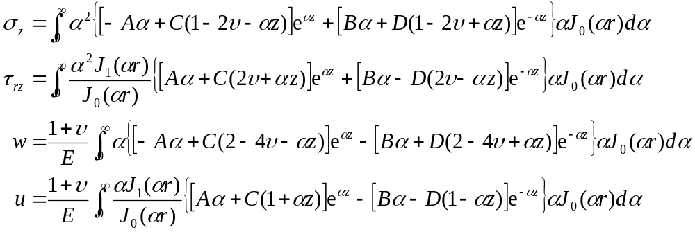 (A-21)

Considering the top layer, which is a special case having a prescribed vertical circular load, p(r), and zero shear stress at the top surface, the complete stresses when z = 0 are:

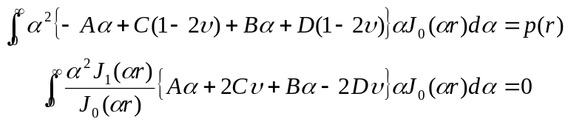 (A-22)

The Hankel transform of a circular load at the origin of intensity q and radius a is (for tension positive):

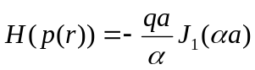 (A-23)

Consequently, the Hankel transforms of the vertical and shear stress equations at z = 0 are:

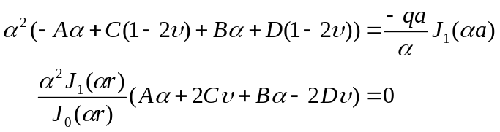 (A-24)

and:

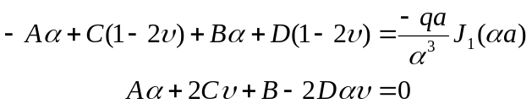 (A-25)

The constants for the top layer are therefore expressed as functions of 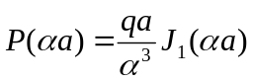, where two equations can be written in four unknowns (the constants). Writing out the stress and displacement equations at either side of each of the remaining interfaces leads to a series of four equations in eight unknowns (the constants for the two layers) which satisfy the boundary conditions. Satisfying the boundary conditions at each interface relates the constants for each layer to those of the layer above. All constants are therefore functions of 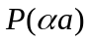. By writing out the equations in matrix form, and synthesizing Gaussian elimination, it can be shown that each constant is a simple multiple of . Therefore, can, if desired be moved into the elemental stress equations and the first element of the right-hand-side vector be set to a value of one.

Boundary conditions for the bottom of the bottom layer require special treatment in the same way as the top of the top layer. If the bottom layer is of infinite extent, two of the constants can be found by multiplying the Hankel transforms of the vertical and shear stress equations through by 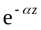, and rearranging:

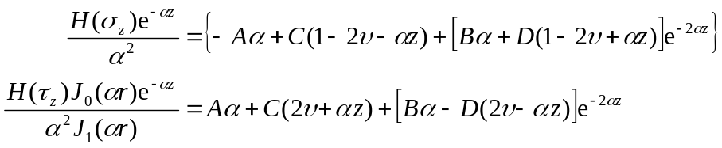 (A-26)

For z = infinity:

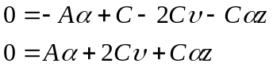 (A-27)

Adding and subtracting the two equations (A-27) gives C = 0 and A = 0.

Stresses and displacements therefore decay as and 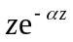 as z increases downward from the subgrade interface.

For a rigid constraint at the bottom of the structure, the two displacement equations must be used to find the two equations in four unknowns.

The form of the boundary condition equations is shown below for a three-layer structure.

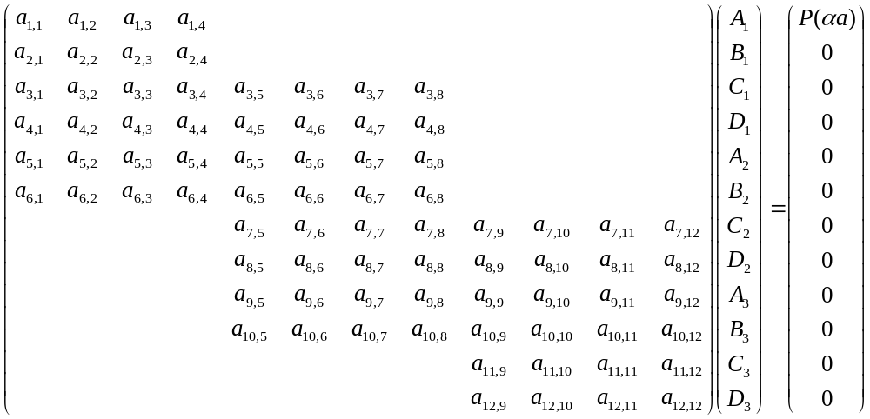

(A-28)
and

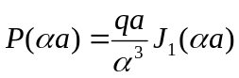 (A-29)

When the bottom layer is of infinite extent, A₃ and C₃ are zero and the corresponding rows and columns can be removed from the coefficient matrix. The number of equations for this case is therefore 4 x 3 - 2 = 10.

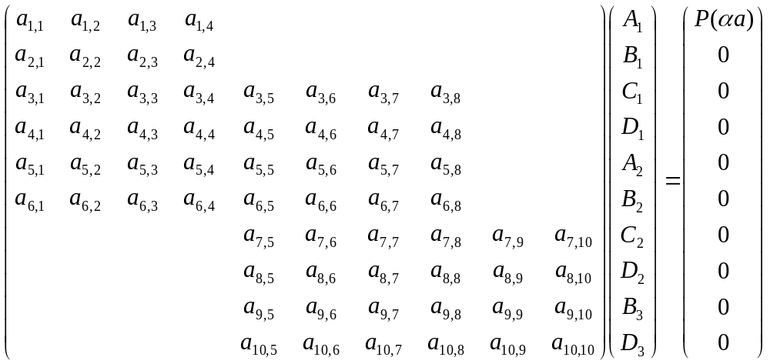 (A-30)

The Boussinesq Case.

The Boussinesq case is for an infinite half space with a circular load at the origin. The solution for vertical stress when radius is zero is (see reference [A-1], page 368):

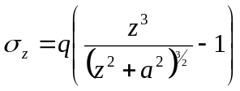 (A-31)

The surface boundary condition for a circular load at the surface is:

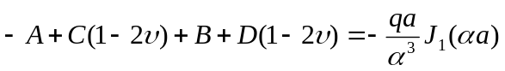 (A-32)

The surface boundary condition for zero shear stress at the surface is:

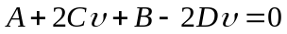 (A-33)

Vertical stress is:

(A-34)

For a solution when z = ∞, A = C = 0, solving the boundary condition equations for B and D gives:

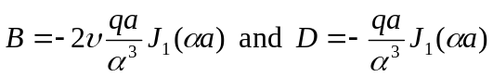 (A-35)

Substitution into the vertical stress equation (A-34) and setting r = 0 gives:

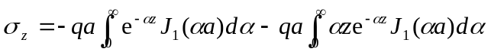 (A-36)

Using relations 6.611(1.) and 6.623(1.) from reference [A-2]:

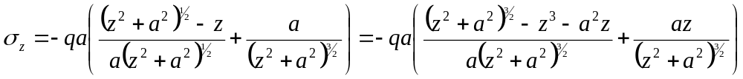 (A-37)

and, rearranging:
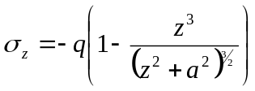 (A-38)

which agrees with the Boussinesq solution (A-31).
References.

A-1. Timoshenko, S., and Goodier, J.N., Theory of Elasticity, Second Edition, McGraw-Hill, 1951.

A-2. Gradshteyn, I.S., and Ryzhik, I.M., Table of Integrals, Series, and Products, Academic Press, 1980

